AS ASSIGNMENT SIX
Name: Anurag Arun Patil
Roll Number: 67
Division: C
Concept: Buffer Overflow attack

What is Buffer Overflow attack ?
A buffer is a temporary area for data storage. When more data gets placed by a program or system process, the extra data overflows.
In a buffer-overflow attack, the extra data sometimes holds specific instructions for actions intended by a hacker or malicious user; for example, the data could trigger a response that damages files, changes data or unveils private information.
Attacker would use a buffer-overflow exploit to take advantage of a program that is waiting on a user’s input.
Types of Buffer Overflow attacks:
1). Stack based
Stack-based buffer overflows, which are more common among attackers, exploit applications and programs by using what is known as a stack memory space used to store user input
2). Heap Based
In Heap based attack, attacker attacks an application by flooding the memory space reserved for a program.

CODE =>
#include <stdio.h>
#include <string.h>

void vulnerable_function(char *input) {
char buffer[10];
strcpy(buffer, input);
printf("Input: %s\n", buffer);
}
int main() {
char input[50];
memset(input, 'A', sizeof(input));
input[sizeof(input)-1] = '\0';
vulnerable_function(input);
return 0;
}

OUTPUT=>
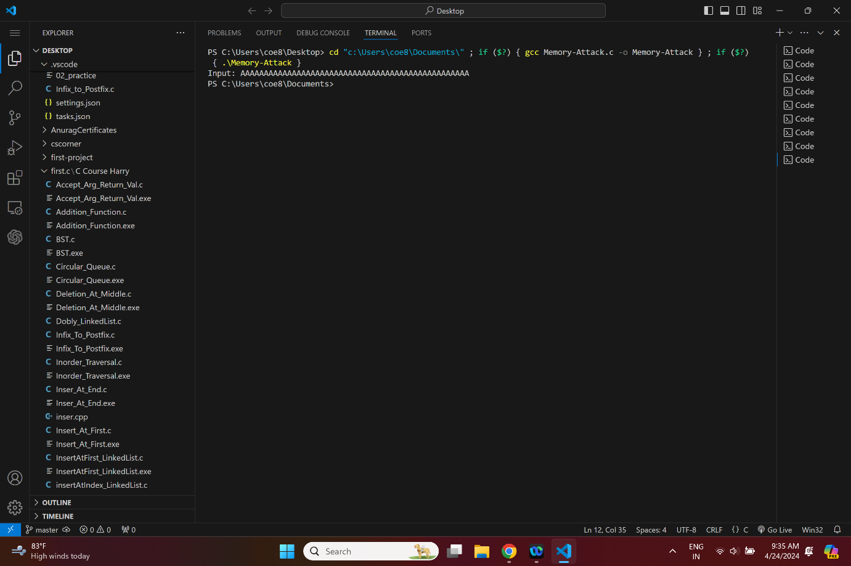

Buffer Overflow Demonstration: The main() function calls vulnerable_function() with the input array as an argument. Since the input array has been filled with 50 'A' characters and null-terminated, it exceeds the size of the buffer array (which can only hold 10 characters). This causes a buffer overflow when strcpy() tries to copy the entire input array into buffer.

